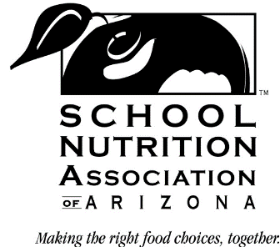
28th Annual – School Nutrition Industry Conference – AGENDA
(May 1-2, 2023)
“Fresh Ideas For School Nutrition”

(MONDAY – May 1, 2023)

9:00 – 9:45 AM Registration/ Round One Industry 1 on 1 Set-Up
(Kiva Ballroom A-side)

9:45 – 10:00 AM Welcome / Opening Remarks / Pledge of Allegiance
Patti Bilbrey, SNAAZ State President /
Brienne Ross, SNIC Chair
(Kiva Ballroom A-side)

10:00 – 10:15 AM Legislative Update
Melissa Reason, SNAAZ PPL Chair

10:30 – 12:00 PM Round One Flash-Networking – Industry 1 on 1 Session
(Kiva Ballroom B-side)

12:00 – 1:00 PM Lunch
(Kiva Ballroom Patio & Ballroom A-side)

1:15 – 2:15 PM Education Part One
Shannon Solomon – Keynote/Education Part One
(Kiva Ballroom A-side)

2:15 – 2:40 PM Energy Break
(Kiva Ballroom A-side)

2:45 – 4:15 PM Round Two Flash-Networking – Industry 1 on 1 Session
(Kiva Ballroom B-side)

5:30 – 6:15 PM Social / Networking Time
(The Canyon Club)

6:15 – 9:45 PM Dinner & Networking – 70’s Disco Theme
(The Canyon Club)

(TUESDAY – May 2, 2023)

8:00 – 8:30 AM Breakfast
(Kiva Ballroom A-side)

8:45 – 10:15 AM Round Three – Industry 1 on 1 Session
(Kiva Ballroom B-side)

11:00 – 12:30 PM Education Session – Part Two
Shannon Solomon – Keynote/Education Part Two
(Kiva Ballroom A-side)

